

WHAT CAN YOU DO TO PREPARE FOR A REVIEW?

You will receive a parental contribution form from the school or Local Authority (LA). Please complete and return to school or the LA.

Think about what you would like to discuss and what your contribution will be. E.g.:

What do you like and admire about your child? (Happy, kind, determined)

What is important to your child? (Activities, friends)

What is important for your child? (Health, behaviour intervention, additional support)

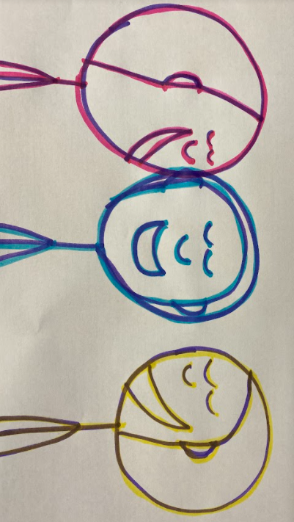What is working well/not working? (What is going well or not for your child)

Questions (Do you have any questions?)

**For more information on the One Page Profile and Person-Centred Planning,**

**please contact your schools ALNCo**

**Mrs Gratton 01633 647488**

**claire.gratton@wcp.schoolsedu.org.uk**



PERSON CENTRED PLANNING

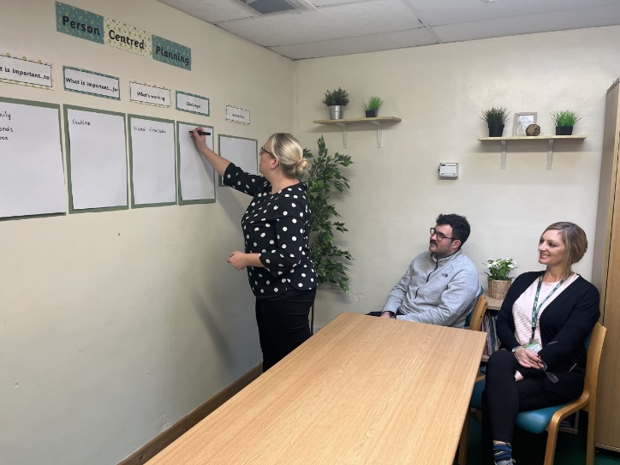

A Guide for   
Parents and Carers

# Torfaen County Borough Council - My Council Services

# WHAT DOES PERSON CENTRED MEAN?

It means focusing on your child. How can you be actively involved with the process of helping the school and others to support your child?

# WHAT IS A PERSON CENTRED REVIEW?

It is all about:

Listening and understanding your child’s views and wishes.

Supporting your child to think about what is important to them and for them.

Helping your child to think about what is working and not working.

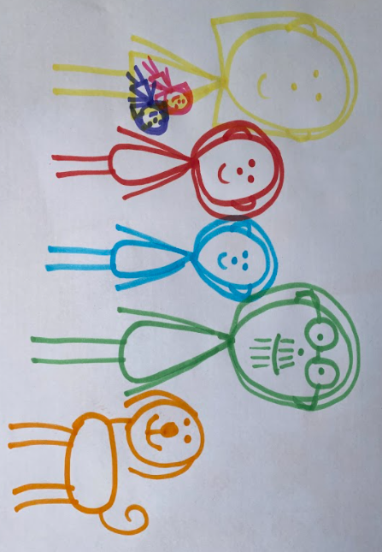Making sure that your child gets the best support from everyone for example, you, the school and other professionals.

# WHAT IS A PERSON CENTRED TRANSITION REVIEW?

This is the process when you and other professionals are involved with supporting your child’s future.

The professionals will have a better understanding of how they can support your child in the way that is needed. A Transition Review is for young people who are 14 years old and over.

# WILL IT BE FORMAL?

Not at all!

It is an opportunity for everyone that is involved with supporting your child to engage together and celebrate their achievements.

It will have a friendly atmosphere and everyone will contribute to develop a realistic action plan for the future of your child.

# WHAT WILL BE DISCUSSED?

Who is present

What we admire and like about your child What is important to your child

What is important for your child

What is working well/not working

Any questions

Action Plan

# DOES YOUR CHILD CONTRIBUTE?

Your child will have their One Page Profile to show at the meeting, stating three key questions:

What people admire/like about me

What is important to me?

How best to support me?

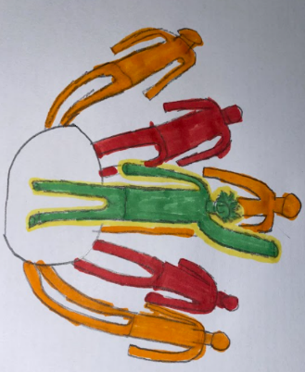The school will prepare your child for the review and if appropriate they will attend. They can use symbols/photographs/write or in some cases a smart board will be used to demonstrate their achievements.